**Hospital & Employee Management System with Patient Tracking**

**1. Introduction**

**1.1 Overview**

The Hospital & Employee Management System with Patient Tracking is a comprehensive digital solution aimed at enhancing efficiency in hospitals. It provides automated patient management, employee records maintenance, AI-powered speech recognition for medical tracking, and appointment scheduling with reminders. The system integrates Streamlit for the user interface, SQL Server for database management, and Google Gemini API for AI-based transcription and data processing.

**1.2 Objectives**

* Automate patient registration, visit tracking, and appointment booking.
* Efficiently manage employee records with auto-generated IDs and structured payroll tracking.
* Implement **AI-powered speech recognition** to transcribe and analyze doctor-patient conversations.
* Enable **real-time tracking of patient test statuses**.
* Securely store and retrieve medical and administrative data using **SQL Server**.

### ****2. Workflow of the System****

#### ****Patient Registration & Management****

#### ****Step 1**** – Patient enters details (name, phone, medical history) in Streamlit UI

**Step 2** – System **auto-generates a Hospital ID** and stores data in SQL Server

**Step 3** – Hospital staff can **retrieve patient details** anytime using the Hospital ID

#### ****Appointment Booking & Notifications****

**Step 1** – Patient selects an available date & doctor through Streamlit UI

**Step 2** – System **stores appointment details** in the database

**Step 3** – System sends **email confirmation** to the patient

**Step 4** – 24 hours before the appointment, a **reminder email is sent.**

#### ****Doctor-Patient Conversation & AI-Based Medical Test Extraction****

**Step 1** – Doctor **records patient interaction** using the system

**Step 2** – Audio is stored and sent to **Google Gemini API** for transcription

**Step 3** – AI **extracts medical tests** from transcribed text

**Step 4** – Extracted tests are **stored in the database** under the patient’s record

**Step 5** – System **updates the test status** (Pending, In Progress, Completed)

#### ****Employee Management****

**Step 1** – HR registers new employees in the system

**Step 2** – System **auto-generates Employee ID** and stores details in SQL Server

**Step 3** – Admin can retrieve and manage **employee records, shifts, and salary**

**Step 4** – Employee details can be **exported as a PDF report**

#### ****Test Tracking & Notifications****

**Step 1** – System **updates test statuses** based on lab results

**3. ARCHITECTURE DIAGRAM**

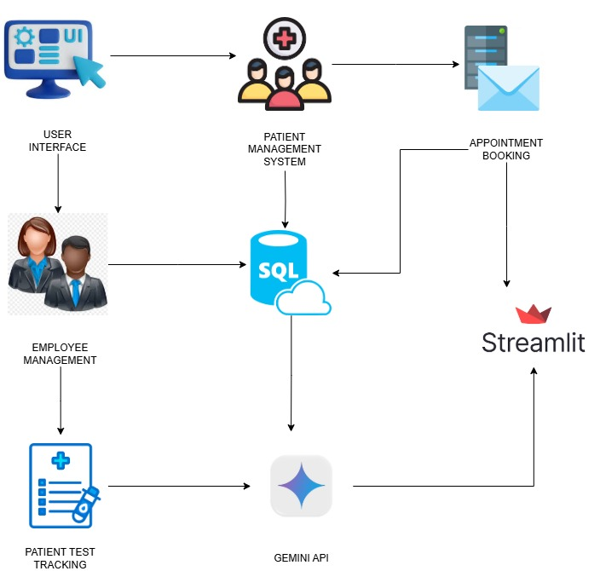

**4. System Features**

**4.1 Patient Management**

The patient management module is designed to streamline hospital workflows and ensure seamless data access.

**Register Patients**

A patient is registered in the system by providing essential details such as:

* **Full Name** – Patient’s complete name.
* **Age** – Patient's age in years.
* **Phone Number** – Contact number for communication and reminders.
* **Address** – Residential address for record-keeping.
* **Medical History** – Chronic conditions, allergies, and prior treatments.
* **Billing Details** – Insurance information or payment method details.
* **Oxygen Level & Vital Signs** – Important for tracking patient health status.

Once registered, each patient receives a **unique Hospital ID**, which serves as a reference for all future interactions.

**Retrieve Patient Records**

Using the **Hospital ID**, hospital staff can retrieve **full patient details**, including:

* Personal and contact information.
* **Complete medical history** (previous diagnoses, allergies, and treatments).
* **Visit records** showing symptoms, medications prescribed, and test reports.
* **Billing and payment status** for hospital treatments.

This feature ensures that patient data is accessible instantly, eliminating the need for manual record-keeping.

**Visit Tracking**

Every time a patient visits the hospital, the system logs:

* **Visit date and time.**
* **Symptoms reported** (fever, cough, chest pain, etc.).
* **Vital signs like temperature, oxygen levels, and blood pressure.**
* **Prescribed medications or recommended tests.**

This visit history helps doctors make informed decisions by providing **a chronological medical history**.

**Appointment Booking**

Patients can book appointments through the system for consultation with specialists. The system allows:

* **Selection of available time slots and doctors.**
* **Confirmation via email notifications.**
* **Rescheduling or cancellation of appointments.**

**Automated Reminders**

To prevent missed appointments, the system sends:

* **Reminder emails** 24 hours before the appointment.
* **Urgent alerts** for patients with critical conditions requiring follow-up.

This feature significantly reduces appointment no-shows and improves patient adherence to treatments.

**4.2 Employee Management**

Efficient management of hospital staff is essential for smooth operations. The system includes **employee registration, payroll tracking, and performance monitoring.**

**Register Employees**

When a new employee is onboarded, the hospital administration enters details such as:

* **Full Name**
* **Department (HR, Technical, Nursing, Finance, etc.)**
* **Role (Doctor, Nurse, Accountant, etc.)**
* **Phone Number & Email Address**
* **Salary Details**
* **Work Shift (Morning, Evening, Night)**
* **Employment Status (Active/Inactive)**

**Auto-generate Employee IDs**

The system automatically assigns a **unique Employee ID** to each staff member, ensuring:

* **No duplicate employee records.**
* **Seamless tracking of employee activities.**

**Retrieve Employee Records**

Administrators can retrieve **full employee details** using the **Employee ID**, including:

* **Contact details and department assignment.**
* **Salary and payroll data.**
* **Shift schedules and attendance records.**

**Generate Employee PDF Reports**

The system can generate **customized PDF reports** containing employee records. These reports can be **downloaded or printed** for HR use, performance reviews, or compliance audits.

**4.3 AI-Powered Patient Tracking**

This module leverages **AI-based speech recognition** to transcribe doctor-patient conversations and track medical test progress.

**Doctor-Patient Audio Recording**

The system records and stores **doctor-patient interactions**, ensuring accurate documentation of:

* **Diagnosis explanations.**
* **Prescribed medications and tests.**
* **Doctor's medical advice.**

The recordings are stored **securely in the SQL Server database** and linked to the patient’s Hospital ID.

**Speech-to-Text Transcription**

Using **Google Gemini API**, recorded audio is transcribed into text. The benefits include:

* **Eliminating the need for manual note-taking.**
* **Ensuring accurate medical documentation.**
* **Improving accessibility of medical records for review.**

**Medical Test Extraction**

The system automatically extracts **prescribed medical tests** from the transcribed text. This helps in:

* **Tracking diagnostic test requirements.**
* **Reducing the chances of missed tests.**
* **Providing a structured view of patient health needs.**

**Test Status Tracking**

The extracted tests are assigned a **status** for efficient monitoring:

* **Pending:** Test has not been conducted.
* **In Progress:** Test is being processed.
* **Completed:** Results are available.

This ensures hospital staff and patients can easily track test progress.

**Automated Notifications**

The system sends **real-time alerts** when:

* **Tests are completed and reports are ready.**
* **A follow-up appointment is needed.**
* **Critical test results require immediate attention.**

These features help in **reducing medical errors and ensuring timely treatment.**

**5. Technology Stack**

| **Component** | **Technology Used** |
| --- | --- |
| **Frontend UI** | Streamlit |
| **Database** | SQL Server (SSMS) |
| **Backend** | Python (PyODBC, Pandas, JSON) |
| **AI Processing** | Google Gemini API |
| **Email Automation** | smtplib (Gmail SMTP) |
| **Audio Processing** | SpeechRecognition, pyaudio, wave |
| **PDF Reports** | FPDF |

### ****Industries & Organizations That Can Benefit from This System****

* **Hospitals & Clinics** – Manages patient records, doctor visits, and medical tests.
* **Diagnostic Labs** – Tracks test results and automates patient notifications.
* **Healthcare Startups** – Integrates AI-driven solutions for digital medical record-keeping.
* **Government Health Departments** – Centralized hospital management for public healthcare.
* **Corporate Health Centers** – Manages employee health records in large organizations.

1. **Conclusion**

This system enhances **hospital efficiency, patient experience, and medical accuracy** while reducing paperwork and administrative overhead. It serves as a **future-ready digital healthcare solution**, with potential enhancements like **real-time AI diagnosis, telemedicine integration, and predictive analytics for patient care. This project represents the next step in intelligent healthcare management, leveraging AI for smarter, faster, and more effective hospital operations.**